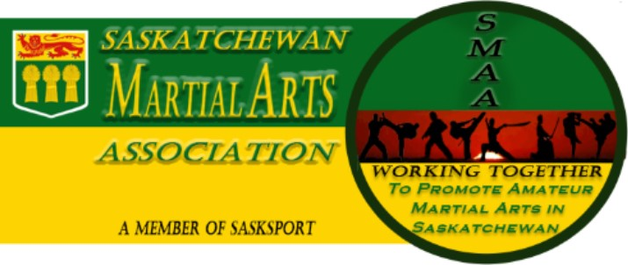
NOTICE OF THE
ANNUAL GENERAL MEETNG

Notice is hereby given that the Saskatchewan Martial Arts Association Annual General Meeting will be held on Saturday June 22, 2019, at the Delta Hotel, Regina, Saskatchewan. Meeting starts at 5:30pm for the following purposes:

- To receive financial statements and the report of the Corporation’s Auditor.
- To appoint auditors for ensuing year.
- To elect Directors of the Corporation.
- To receive a report from the Board of Directors, Committees and Delegates.
- To deal with any Resolutions brought forward.
- To deal with any Constitution changes brought forward.

***All resolutions must be received no later than 15 days prior to the AGM in writing.
***Nominations to the Board must be received no later than 1 week prior to the AGM (June 15, 2019).

Please RSVP to ed@saskmartialarts.ca

By the order of the Board of Directors.

Kim Delesoy
President

Encl.: Saskatchewan Martial Arts Association Constitution

Sent to: Saskatchewan Martial Arts Member Clubs
SaskSport Inc. Consultant Warren Proctor

